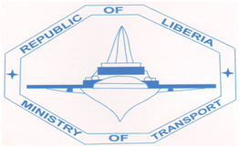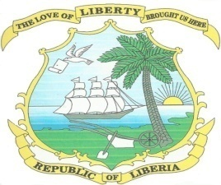

MINISTRY OF TRANSPORT

WARREN & CAREY STREETS

MONROVIA, LIBERIA

**July 23, 2024**

**INVITATION TO BID (IFB)**

The Ministry of Transport (MOT) was established by an Act of the National Legislature on August 25, 1987, to administer the transport, insurance and maritime regulations and policies of Liberia. These include the oversight responsibility for execution of policies relating to land, sea and air transport services operating within the Country.

1. The Ministry of Transport (MOT) has received budgetary allocation for Fiscal Year 2024 from the National Road Fund of Liberia and intends to apply part of it towards the procurement of Specialized goods as indicated in the chart below:

1. The Ministry now invites sealed bids from eligible and registered bidders for the procurement of these goods for Fiscal Year 2024.
2. Bidding will be conducted through the International Competitive Bidding (ICB) Method as enshrined in the Public Procurement and Concession Act (PPCA) as amended and restated in 2010.

1. Schedule of Requirements:

|  |  |  |  |  |  |
| --- | --- | --- | --- | --- | --- |
| **Item #** | **Description of**  **Goods / Services** | **Quantity** | **Delivery** | | |
| 1. | ELECTRONIC SIGNBOARDS;  **Including Installation**  (IFB NO. MOT/RSS/PROJ/ICB/001/24) | Assorted | See Bidding Documents | | |
| 2. | ROAD SAFETY MANAGEMENT MATERIALS;  **Including Installation**  (IFB NO. MOT/RSS/PROJ/ICB/002/24) | Assorted | See Bidding Documents | | |
| 3. | TRAFFIC LIGHTS MOUNTED WITH CCTV CAMERA;  **Including Installation**  (IFB NO. MOT/RSS/PROJ/ICB/003/24) | Assorted | See Bidding Documents | | |
| 1. Detailed specifications, description and qualification requirements of the above contract packages are provided in separate bidding documents. 2. All interested eligible bidders may obtain copy of Bidding Documents upon payment of a non-refundable fee of Two Hundred United States dollars (**$200.00 USD)** *to* the Procurement Unit at the Ministry before issuance by the Procurement Unit between 10:00 am to 3:00 pm daily. | | | | |  |  |

1. All interested eligible bidders may obtain further information form and inspect the bidding documents at the office of the Director of Procurement, Ministry of Transport, Republic of Liberia between 8:00am to 4:00pm until Sept 6, 2024.
2. A complete set of bidding document in English Language can be obtain from the address below before the expiration of the submission of bid.
3. Bid must be submitted to the address below on or before Sept 6, 2024. Electronic bidding will not be permitted and late bids will be rejected.
4. Bids will be publicly opened in the presence of the bidders designated representatives who choose to attend in person at the address below at 10:am on Sept 6, 2024.
5. All bids must be accompanied by a “Bid Security” as per the form specified in the forms of the Biddings Document for the amount of 20% of your bid price of as per the Bid Date Sheet

The preferred address is:

**Director of Procurement**

**Procurement Unit**

**1st Floor, Procurement Unit**

**Ministry of Transport**

**Warrant & Carey Streets**

**Monrovia, Liberia.**

Signed: **EDWARD BOIMA CLARKE SR**.

**DIRECTOR OF PROCUREMENT**

(231)770239073/0881617551

Clarkeedward1970@gmail.com